Insertion port-a-cath

Discharge Instructions

- Rest at home today and gradually increase your activity as tolerated. Do not drive a car or sign any legal documents today. Have someone drive you home.

- You may shower using plain soap and water as desired. Carefully dry your dressing after shower.

- Pain management at home: take Panadol 1g every 6 hours as required.

- Please refrain from heavy lifting or vigorous exercising (aerobics and weight lifting) for one week.

- You can remove your dressing on day 3 after your procedure.

Contact Dr. Nascimento (Pager 07 56765036) at any time if you experience:

- Severe pain or shortness of breath, severe nausea or vomiting, or shaking chills.
- Fever over 38°C.

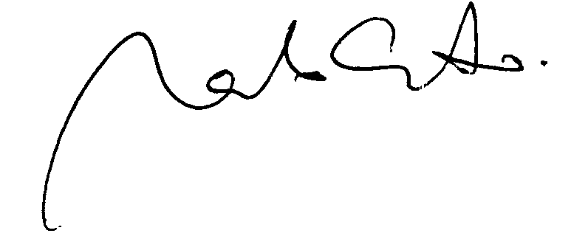

Dr. Marcelo Nascimento

