Laparoscopic Surgery
Discharge Instructions
Medication:
- Resume your preoperative routine medications.
- Take your pain medications and/or antibiotic as explained to you by our nurses.

Constipation:
- Some changes in your bowels are normal following any surgery. Constipation may last for a couple of weeks after the procedure. To prevent this, drink 6-8 glasses of fluids per day, eat high fibre foods, prunes, etc. Metamucil or Coloxyl with Senna are okay. Call during office hours if these methods are ineffective.

Wound Care:
- Wound care: keep your dressings for 48 hours, and then it is ok to peel them off while you are having your shower. If you only have glue dressings, they will peel off by themselves in a few days and you don’t have to remove them.
- No baths or swimming pool exposure for 4 weeks if you had a total laparoscopic hysterectomy (TLH), or for 1 week for any other procedures e.g. removal of cysts, ovary(s).
- It will take up to 6 months for your incision to mature into its final form. Ridges and raised red scars will diminish in time and smooth out.
- Notify your local doctor or call the rooms if the wound becomes red, irritated, or purulent discharge develops. A small amount of blood or clear discharge is normal initially.
- Some mild abdominal distention and/or cramping are normal. Occasionally, patients report right shoulder pain. A warm heating pad and walking should relieve the discomfort.
- Sutures will dissolve and fall out in 2 to 3 weeks, you don’t have to remove them, just keep them clean and dry.

Activity:
- After surgery, take it easy for 4 or 5 days before resuming your routine.
- No driving for a week after surgery or while you are on prescription pain medications. Please make sure your health insurance company is going to cover you when you start driving.
- It is important to be up and out of bed, walking, but you may fatigue easily. It is important to get enough rest.
- There is no limit to stair climbing.
- Limit yourself to light housework (i.e., dusting) for 1 week.
- No intercourse for 8 weeks if you had a Total Laparoscopic Hysterectomy and for 2 weeks if you had any other laparoscopic procedure. Gradually increase your level of activity; and remember to listen to your body - IF IT HURTS - DON'T DO IT!

Normal post-surgery changes:
- You will be bloated for 1-2 weeks following your surgery. This will improve with activity.
- Some abdominal bruising is normal, as is drainage and small bleeding from your incisions.
- Vaginal bleeding and discharge are normal for up to 6 weeks.

Follow-up:
- If not already scheduled, please call our office at your earliest convenience to make an appointment for 2 weeks after your surgery: 07 55645110.
- If you have questions or concerns before this appointment, please call the rooms for assistance.
- Reports from biopsies and final histopathology specimens will be received by Dr. Nascimento within 5 to 7 working days. Dr Nascimento will contact you with the results or discuss them with you on your follow-up visit.

Contact Dr. Nascimento (Pager 07 56765036) at any time if you experience:
- Bleeding heavier than a period.
- Severe abdominal or back/flank pain, severe nausea or vomiting, or shaking chills.
- Fever over 38°C.
- Burning on urination or inability to urinate.

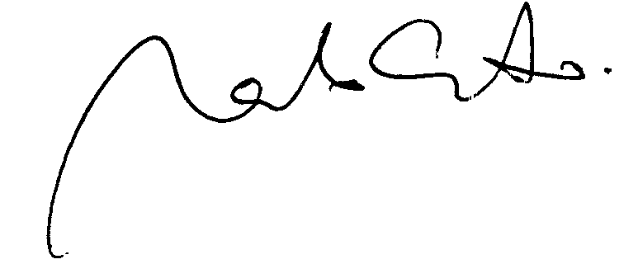
Dr. Marcelo Nascimento

