Groin lymphadenectomy
Discharge Instructions
- Rest at home today and gradually increase your activity as tolerated. Do not drive a car or sign any legal documents today. Have someone to drive you home.

- Please refrain from sexual intercourse for 1 week.

- You may shower using soap and water as desired but avoid baths for 2 weeks after your procedure.

- Wound: occasionally, there is a yellow to bloody water discharge, or a dark brown dirt-like discharge. This is normal and should be controlled with your dressing.

- Wound care: keep your dressings for 48 hours, and then it is ok to peel them off while you are having your shower. If you only have glue dressings, it will peel off by itself in a few days and you don’t have to remove it.

- Pain management at home: take Panadol 1g every 6 hours as required.

- Please refrain from heavy lifting or vigorous exercising (aerobics & weight lifting) for at least 1 week after your surgery. After that you should resume your activities gradually.

- You have an appointment to see Dr. Nascimento in a couple of weeks’ time. If this has not been organised, please call our rooms and we will do it for you.

- Reports from biopsies and final histopathology specimens will be received by Dr. Nascimento within 5 to 7 working days. Dr Nascimento will contact you with the results or discuss them with you on your follow-up visit.

Contact Dr. Nascimento (Pager 07 56765036) at any time if you experience:
- Severe nausea or vomiting, or shaking chills.
- Fever over 38°C.
- Foul-smelling wound discharge that persists for more than 2 days.
- Progressive swelling on the groin were biopsy was taken in association with pain.

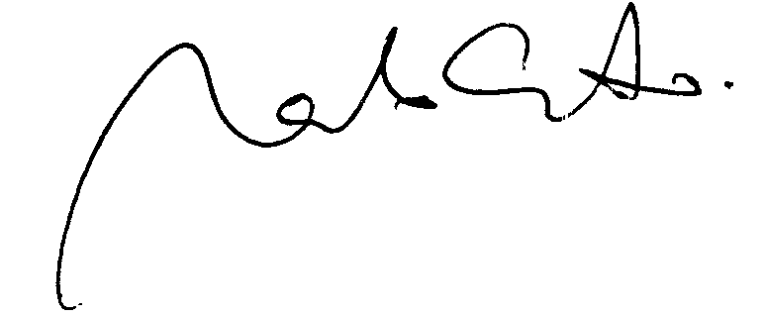
Dr. Marcelo Nascimento

