

**Insertion of**

**Intra-peritoneal port**

**Discharge Instructions**

* Rest at home today and gradually increase your activity as tolerated. Do not drive a car or sign any legal documents today. Have someone drive you home.
* You may shower using plain soap and water as desired. Carefully dry your dressing after shower.
* Pain management at home: take Panadol 1g every 6 hours as required.
* Please refrain from heavy lifting or vigorous exercising (aerobics and weight lifting) for one week.
* You can remove your dressing on day 3 after your procedure.

**Contact Dr. Nascimento (Pager 07 56765036) at any time if you experience:**

* Severe abdominal pain, severe nausea or vomiting, or shaking chills.
* Fever over 38°C.

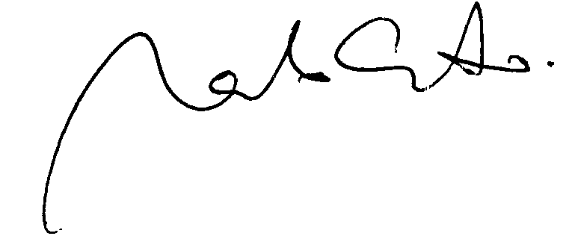

Dr. Marcelo Nascimento